Those are items that each student has to do two times a year during the Fall/Winter and Spring/Summer terms. The only item that you will only have to do one time is agree to the Fair Use Agreement. The other agreements must be done two times a year, once during each registration period. I am using a pretend student named Missy Masters to show you how to step through the registration rules. Below this paragraph is also a link to a recording from when we did the student training on the new Colleague Self-Service system. It is a little less than an hour long but most students have found it to be quite helpful.

<https://vimeo.com/743521449/65ec235947>

After you log into Colleague Self-Service you will do the following:

* For home address, click on your name in the upper right corner of the home page. It will show you these options. You will click on “User Profile”. Which will take you to the screen where you will confirm your home address, email address and cell phone number.

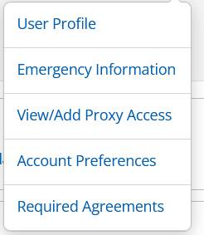

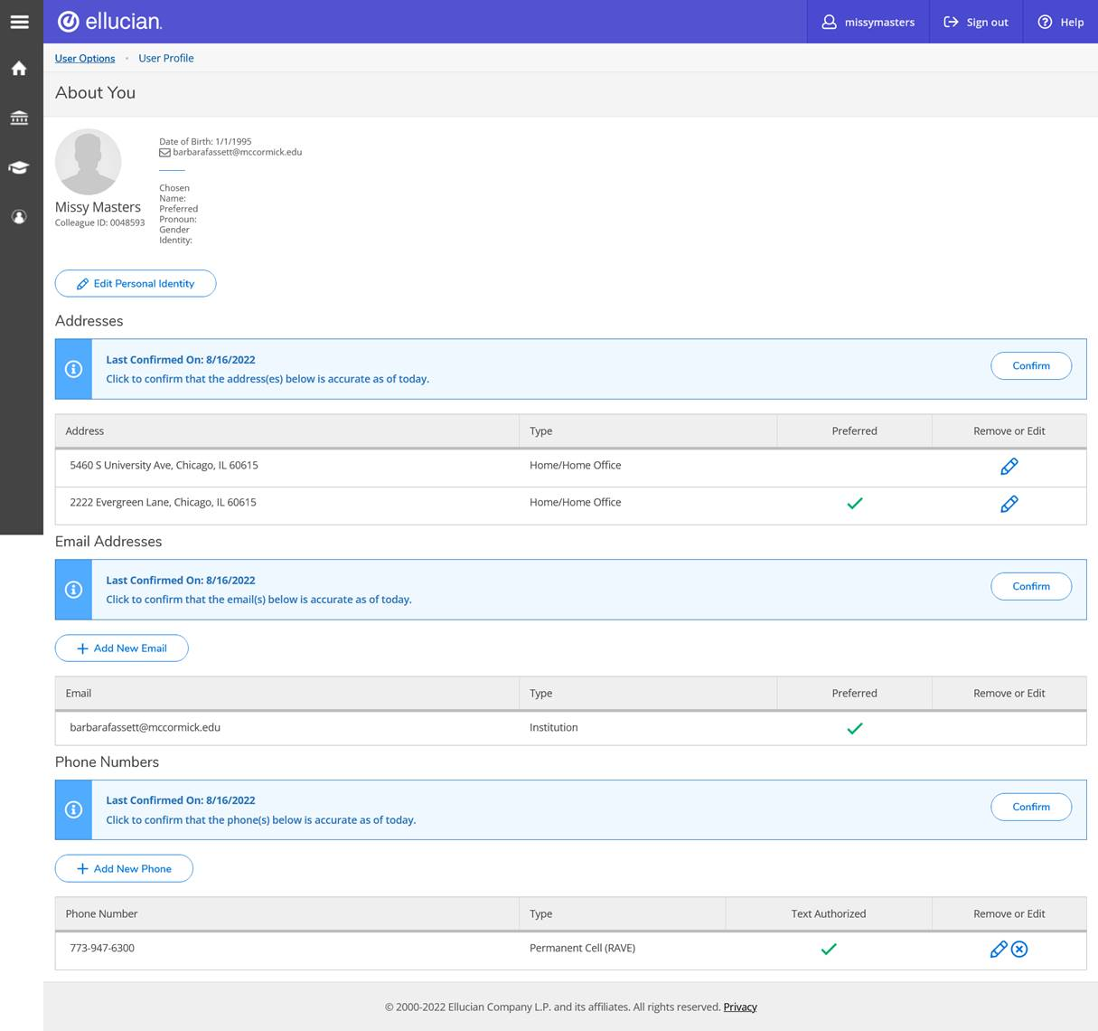

               Once you have done this step, that particular message will disappear.

* Next thing you do, is to again click on your name. You will get the drop down menu. This time you will select “Required Agreements”.



You will then click on “View” for each of the agreements. It will open the agreement. You will want to read it. You can print it as well if you choose. You will then need to accept each agreement.

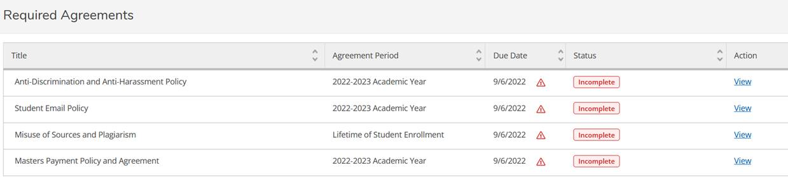

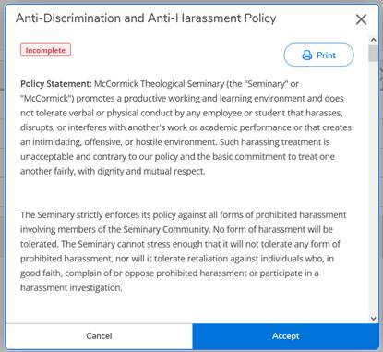

* Once you have done that, those requirements will disappear and you will be able to register. The next time you click on “Required Agreements” you will see the status that each agreement has been accepted, and the date they were accepted. Below is an example from a test student’s account. You can always click on “view” under the Action column and view the agreements at any time.

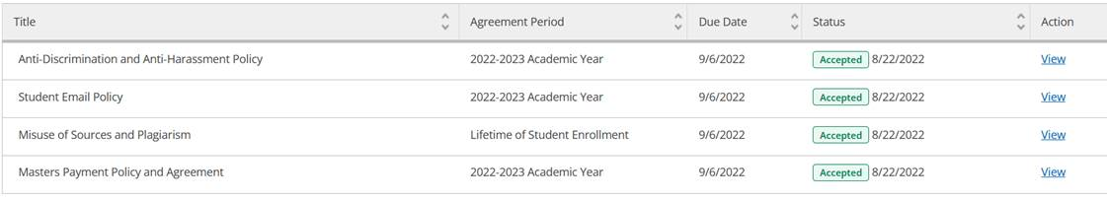

Once these steps are completed, they will no longer show when you go to register for classes. After you do these steps, let us know if you need further assistance.